# Validating the CKD Model

#### Version 2 – 29 May 2025

## Introduction

Validation is the process of ensuring that the model is sufficiently accurate for the purpose in hand, and is vital to create enough confidence for the results to be accepted.

In this project, the participative approach to building the CKD model has contributed to validating the conceptual model – that the constituent parts of the model represent the real world with sufficient accuracy.

Further validation is needed to address whether, overall, the model represents a sufficiently accurate representation of the real-world system.

Black-box validation considers the overall behaviour of the model (as opposed to constituent parts). The CKD model has been compared to other models that similarly aim to project prevalence of CKD, but that have used different methodologies. When comparing with other models there is an assumption that those models are equally valid, which may not be the case and therefore judgment and caution is required.

## Models used in cross-validation

(where relevant, figures have been scaled to England population)

|  |  |  |
| --- | --- | --- |
| **Model** | **Methodology** | **Details** |
| [IMPACT CKD (2024)](https://doi.org/10.1016/j.ekir.2024.08.015) | Micro-simulation | Projects from 2022-2032  Baseline prevalence based on HSE 2016 |
| [Inside CKD (2024)](https://doi.org/10.1016/j.eclinm.2024.102614) | Micro-simulation | Projects from 2022-2027  Baseline CKD prevalence by stage sourced from CPRD-HES linked data (Appendix S2 of Rationale and Methods of Inside CKD) |
| [UKKR (2023)](https://www.kidneyresearchuk.org/about-us/policy/health-economics-report/) | Epidemiological modelling | Projects from 2022-2032  Prevalence based on HSE 2016  Not all results were explicitly reported – IMPACT CKD extracted data to use in their cross-validation |
| [PHE (2014)](https://assets.publishing.service.gov.uk/media/5a82c379e5274a2e8ab593af/ChronickidneydiseaseCKDprevalencemodelbriefing.pdf) | Multilevel small area synthetic estimation (ML-SASE) | Projects from 2011-2036  Based on HSE 2010 |

## Cross-Validation

### Diagnosed as a proportion of total prevalence

Total prevalence is a combination of diagnosed and undiagnosed. ‘Impact CKD’ and UKKR used HSE 2016 as the baseline for total prevalence, then used figures from HSE 2016 to determine the split between undiagnosed and diagnosed. ‘Inside CKD’ used CPRD-HES linked data to determine prevalence by stage, and so can be considered more robust than deriving figures from HSE 2016.

As the CKD model uses quarterly data from CVD Prevent for both diagnosed and undiagnosed (see accompanying ‘Initialising & calibrating prevalence’ paper for details) the proportion of the total who diagnosed is more dynamic, and increased from 65% in 2022 to 70% in 2024.

|  |  |
| --- | --- |
| **Model** | **Diagnosed as % of total** |
| SD CKD | 65%, 68%, 70% |
| Inside CKD | 39% |
| Impact CKD | 68% |
| UKRR (2023) | 70% |

### Total Prevalence of CKD

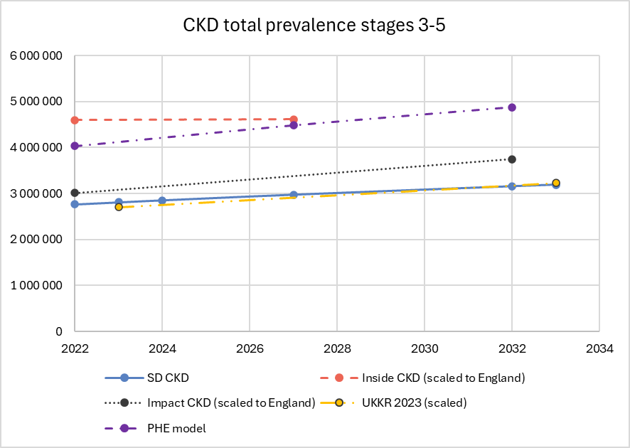

The SD CKD model is initialised using data from CVD Prevent for both diagnosed (CVDP001CKD) and undiagnosed (the sum of CVDP002CKD and CVDP003CKD). Except for ‘Inside CKD’, all models project growth in total prevalence. For the SD CKD model, this is driven by a growth in diagnosed prevalence.

### Diagnosed Prevalence of CKD

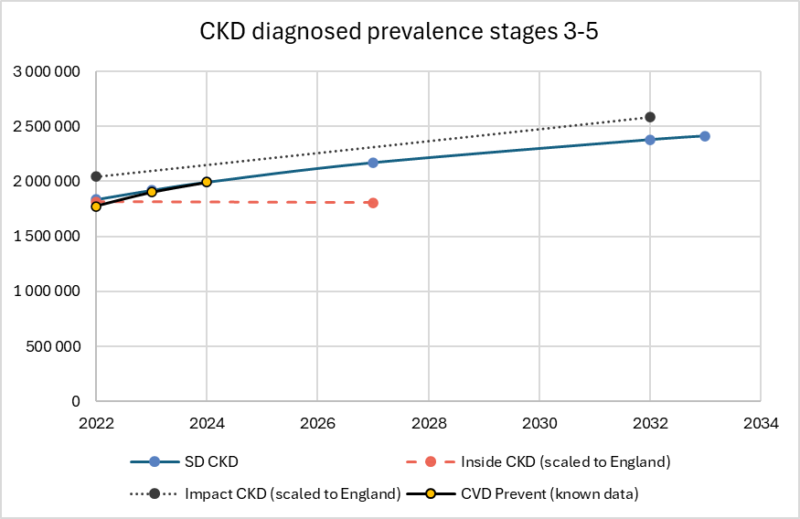

The SD CKD model is initialised and calibrated using the reported figures from CVD Prevent (March 2022 to June 2024). ‘Inside CKD’ models a reduction in the prevalence of diagnosed CKD, whereas ‘Impact CKD’ starts with a higher prevalence but matches the growth rate of the SD CKD model. UKKR did not report values for diagnosed.

### Undiagnosed Prevalence of CKD

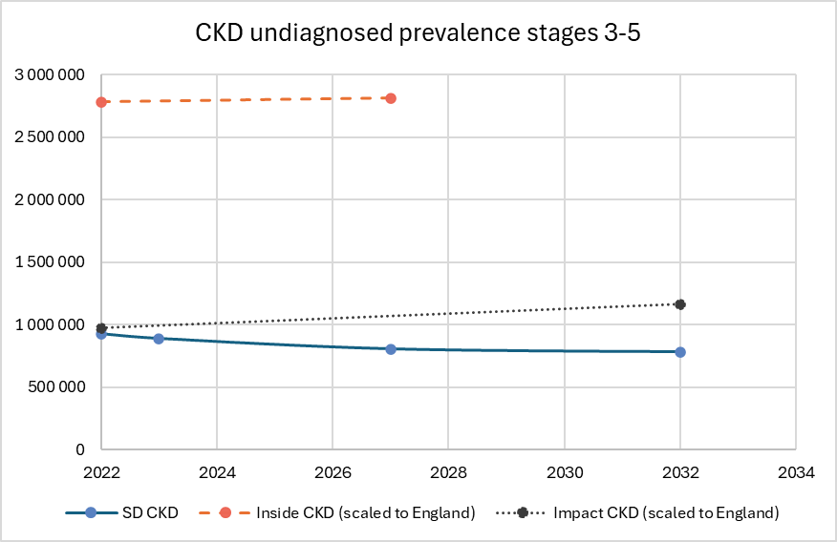

Due to a lack of clarity about how undiagnosed is defined in each model, there are large differences in the undiagnosed prevalence. The CKD model projects a fall in undiagnosed prevalence, which is consistent with increasing diagnosis (see the table indicating diagnosed as percentage of total) being reported to CVD Prevent.

### Prevalence of KRT

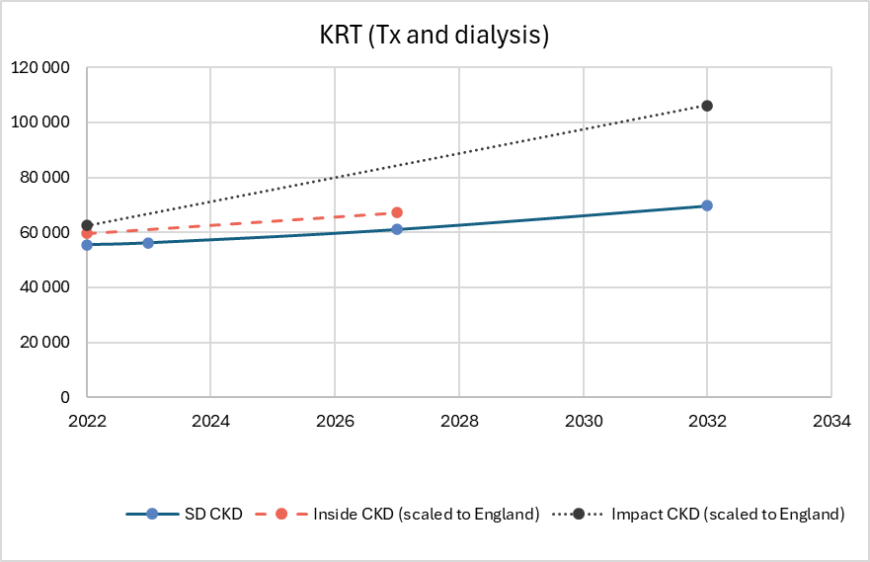

Growth in the prevalence of people receiving KRT is slower in the SD CKD model than that of ‘Impact CKD’. UKKR reported prevalence of dialysis and annual incidence of new transplants, so it is not possible to derive figures for total prevalence of KRT.